**MIDDLE EAST TECHNICAL UNIVERSITY**

**DEPARTMENT OF ELECTRICAL & ELECTRONICS ENGINEERING**



**TROY TECH**

**WEEKLY REPORT #10**

**12.12.2018-20.12.2018**

**Section :** 7

**Studio Coordinator:** Mustafa Mert ANKARALI

**Partners :**

Hasan ÖZKARA - 2031888

Kağan ÖZASLAN - 2031854

Caner POTUR - 2031250

Mustafa Ercan OKATAN - 2031193

Mert KAYIŞ – 2030997

**Progresses for Previous Week:**

* We tested the command transfer unit using NRF24L01 with 15dBi 2.4Ghz linear antenna and 25dbi 2.4GHz Yagi antenna alternately. Both antennas increased the maximum transmission range widely.

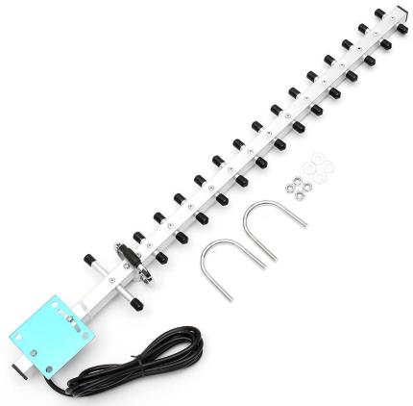

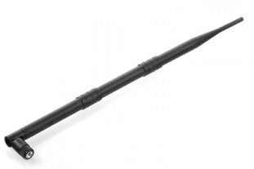

* 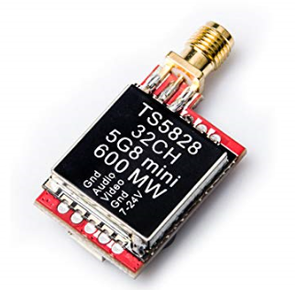We bought a new FPV transmitter: Eachine TS5828S 40CH 5.8G 600MW. It can transmit the video from the 1st floor of E building to ground, first and second floor of D building and up to study hall in D building smoothly.
* We created a RC robot using two DC motors, power units, FPV transmitter and command receiver for demo:

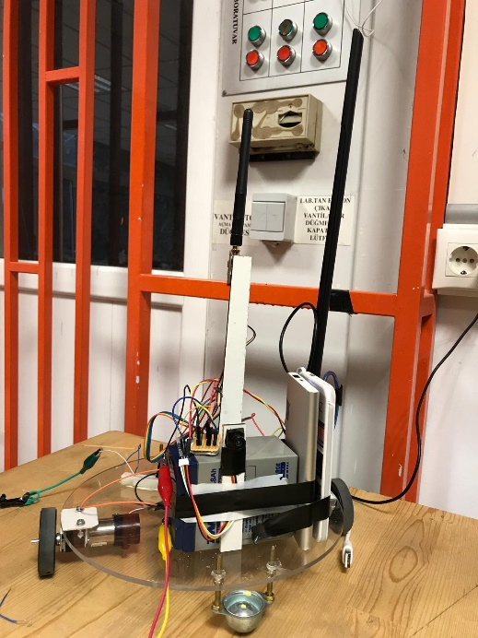

* We created a transmitter unit including PS1 joystick and transmitter. By using this unit, robot can move forward-backward and turn around itself with different speeds. Speed can be adjusted using analogs(3 different speed options for all movements.)

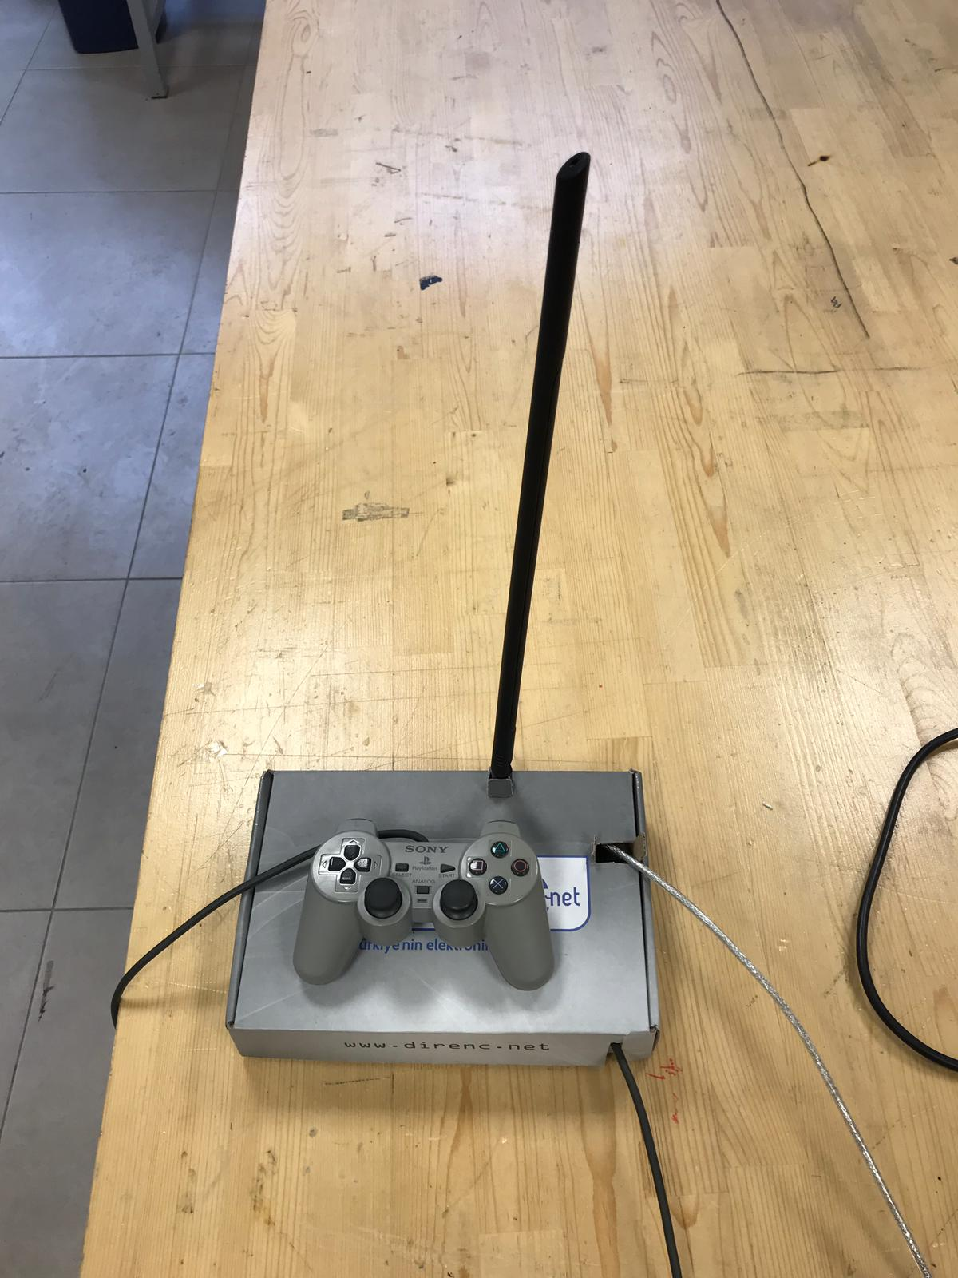 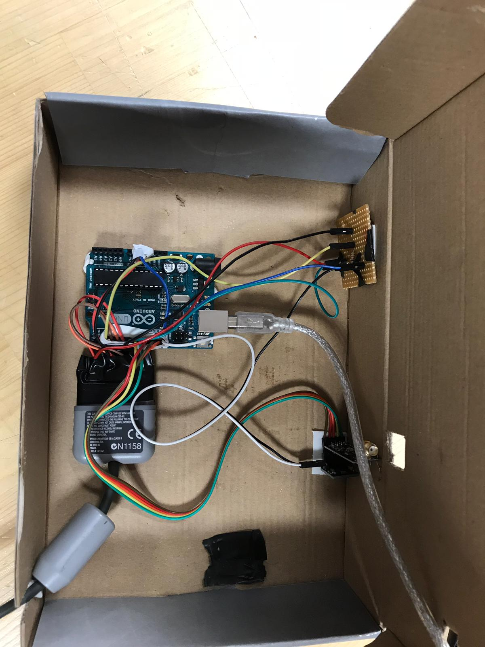

**Plans for the Next Week:**

* Writing conceptional design report
* Preparing a presentation
* Testing the robot